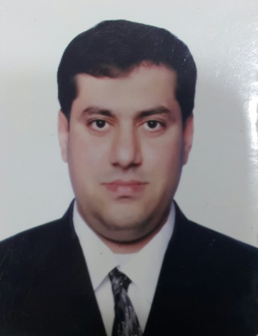



AHMED ABDULLA

JUMA ALBURI



OBJECTIVE

# CONTACT

Image result for icon phone

+973 39076965

wald_jma3a@hotmail.com

VILLA 802, ROAD 5431, 754 Block Buri , Kingdom of Bahrain

 **DATE OF BIRTH:** 21.12.1983

**CPR. NO:** 831205172

 **NATIONALITY:** BAHRAINI

**STATUS:** MARRIED

# LANGUAGES

# 

SKILLS

* Computer Literate, Internet, Computer Maintenance & Formatting.
* Telecommunications Technician.
* Customer service.
* Electricity works.
* Using Microsoft word, excel, power point.

# 

# HOBBIES

https://lh6.googleusercontent.com/iZZkXgXWdNRGfI3q6-uU0fz7VmDfAlWGtMVuCHySgb3A5ZMKYfXODuusph79xDnOJC9kkjEowQPPlzRF137hLco00p2ZyZXb_XupCNUlhqvYohi2BZYN_lvLPkKAUXDUqsC5X1E9nfHmnA

Right now, I am looking for a suitable position with a organization that hires innovators, and where capabilities mean more than just titles to and I want to continuously enhance my competencies, make every opportunity as learning one and excel in my chosen profession.

# EDUCATION

## 2005-2007

## Bahrain Training Institute

## BTEC National Diploma in Instruments & process control

## 2004-2005

## Bahrain Training Institute

## BTEC First Diploma in Instruments & process Control.

## 1999-2003

## Sheikh Abdulla Technical Secondary school for boy Technical Secondary Certificates (Office Equipment & Systems).

# WORK EXPERIENCE

English

Arabic



## Jan 2018 - Dec 2018 Almanor Bakeries as Salesman

## Responsibilities:

## Customer Services

## Help to the Customer and fulfill their requires.

## Deal with the Clients.

## Oct 2009 – May 2017 Bukhowa investments (food court) as Assistant manager

## Responsibilities:

## Help the manager

## Finish all work as the manager request.

## Feb 2008 – May 2008 Horizon Telecom Services (Batelco) as Technician

## Responsibilities:

## Responsible for all technical transactions

## Solve the technical problem

## Jan 2009 - Nov 2009 Signal pcs (Zain Company) as Technician

## Deal with Clients.

## Learn how to deal with customer.

## TRAINING MAR 2003-APR 2003 in Continental Office Equipment & System.

## TRAINING FEB 2008- NOV 2008 in Bahrain Telecommunications Company (Batelco).